Name________________________________ Date________________________
Chapter 4: Founding Colonies in North America

True/False
Indicate whether the statement is true or false.

____ 1. The waters that surrounded the settlement at Charlesfort were named Port Royal Sound.

____ 2. An indentured servant agreed to 7 years of work in exchange for passage to America.

____ 3. New York was first settled by the Swedes.

____ 4. The Puritans were the dominant religious group in New England.

____ 5. The first permanent English settlement in America was Jamestown in 1607.

Multiple Choice
Identify the choice that best completes the statement or answers the question.

Columbus’s Journal-1492
(This entry describes Columbus’s encounter with American Indians)

. . . in order that they would be friendly to us--because I recognized that they were people who would be better freed and converted to our Holy Faith by love than by force--to some of them I gave red caps, and glass beads which they put on their chests, and many other things of small value, in which they took so much pleasure and became so much our friends that it was a marvel. Later they came swimming to the ships’ launches where we were and brought us parrots and cotton thread in balls and javelins and many other things, and they traded them to us for other things which we gave them, such as small glass beads and bells. In sum, they took everything and gave of what they had very willingly. But it seemed to me that they were a people very poor in everything. . . .Their javelins are shafts without iron and some of them have at the end a fish tooth. . . .All of them alike are of good sized stature and carry themselves well. I saw some who had marks of wounds on their bodies and I made signs to them asking what they were; and they showed me how people from other islands nearby came there and tried to take them, and how they defended themselves.

____ 1. According to the journal, what product did the Indians give to Columbus?
A. | cotton thread
B. | gold
C. | tobacco
D. | tropical fruit

____ 2. According to the journal, which statement explains Columbus’s attitude toward the Indians?
A. | He believed they could not be trusted.
B. | He thought they were friendly and peaceful.
C. | He was fearful of them because of their large stature.
D. | He believed they were backward people who could be of no help to him.

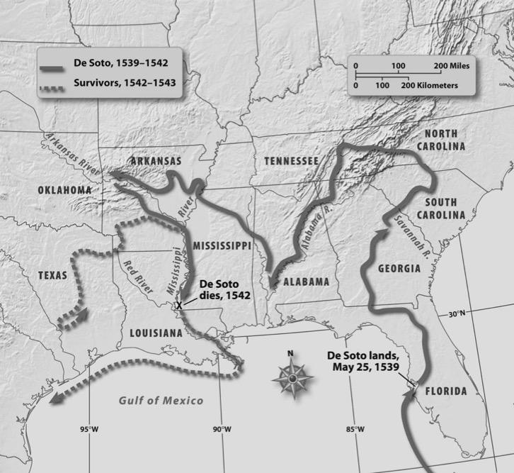

____ 3. According to the map, where did de Soto begin his expedition in North America?
A. | in present-day Florida
B. | in present-day Georgia
C. | in present-day Mississippi
D. | in present-day Tennessee

____ 4. The voyage of Hernando de Soto covered a large area. What is the correct chronological order for the places de Soto visited on his travels?
 | 1. | present-day Alabama
 | 2. | present-day Florida
 | 3. | present-day South Carolina
 | 4. | present-day Mississippi

A. | 3, 1, 4, 2
B. | 2, 3, 1, 4
C. | 4, 3, 1, 2
D. | 2, 1, 3, 4

____ 5. Why did all the settlers leave Charlesfort?
A. | They ran out of food.
B. | The Indians killed more than half the settlers.
C. | They believed they had been deserted by their leader.
D. | They were homesick and wanted to return to Europe.

____ 6. What was the purpose of the Spanish base at Fort San Marcos?
A. | availability of a large mound on which to build a fort
B. | to protect shipping lanes from Mexico, Peru, and the Caribbean Islands to Spain
C. | to establish a slave colony
D. | to move away from Florida because of the heat

The leaders of the Virginia Company recruited more settlers and reorganized the colony. They allowed the new settlers to own land. Those settlers began to grow tobacco, a crop they learned about from the Indians. By 1612, Virginians were shipping tobacco to England, which led other settlers to come over and try their hand at raising the crop. Because growing tobacco required large plots of land, the small tobacco farms grew into large farms, or plantations. Tobacco soon became the backbone of the Virginia economy and the first cash crop grown in America.

____ 7. What is the main idea expressed in the reading?
A. | the bad effects of growing tobacco
B. | the role tobacco played in the economy of Virginia
C. | the attempts of the Virginia Company to recruit settlers
D. | the favorable conditions in Virginia for growing tobacco

____ 8. Based on the information in the passage, which statement contains a prediction of what might happen as a result of growing tobacco?
A. | The land will become infertile.
B. | The settlers will leave Virginia.
C. | The large plantations will need more workers.
D. | The market will be flooded with tobacco, causing the price to decrease.

English Colonies 1607-1732

Colony | Date of Settlement | Leaders | Reasons for Settlement | Type of Colony
Virginia | 1607 | John Smith | Commercial venture | Royal
Massachusetts | 1629 | Puritans (John Winthrop) | Religious freedom | Royal
Maryland | 1632 | Catholics, Calverts | Religious freedom | Proprietary
Connecticut | 1636 | Thomas Hooker | Religious freedom | Royal
Rhode Island | 1644 | Roger Williams and Anne Hutchinson | Religious freedom | Self-governing
New York | 1664 | Dutch (Peter Minuit) | Trade | Royal
New Jersey | 1664 | George Carteret and William Berkeley; Swedes | Farm land | Proprietary/Royal
New Hampshire | 1680 | Puritans | Religious freedom | Royal
Pennsylvania | 1681 | William Penn and Quakers | Equality, antiwar | Proprietary
Delaware | 1704 | William Penn and Quakers | Equality, antiwar | Proprietary
North Carolina | 1712 | Lords Proprietors | Make money from rents | Proprietary/Royal
South Carolina | 1719 | Lords Proprietors | Make money from rents | Proprietary/Royal
Georgia | 1732 | James Oglethorpe | Debtors | Proprietary/Royal

____ 9. According to the chart, what was the primary reason for establishing the English colonies?
A. | to make money for private companies
B. | to establish trade with the Indians
C. | to find a source of gold and silver
D. | to secure religious freedom

____ 10. According to the chart, which colony was established as a haven for Catholics?
A. | Delaware
B. | Maryland
C. | New Jersey
D. | Rhode Island

____ 11. According to the chart, how long were the English involved in settling the first thirteen colonies?
A. | 100 years
B. | 115 years
C. | 120 years
D. | 125 years

____ 12. Which country was NOT a major colonizer of the New World?
A. | England
B. | France
C. | Italy
D. | Spain

____ 13. Jamestown had a very uncertain and miserable existence for many years because
A. | they found lots of gold.
B. | the people would not work.
C. | the weather was always bad.
D. | the owners were lacking in ability.

Completion
Complete each statement.

1. The first legislative body in America was the _________________________.

2. The first explorer to possibly see the interior of the present-day state of South Carolina was ___________________.

3. The first effort to establish an English colony in North America on the outer banks of present-day North Carolina was led by _______________________.

Matching

Match the term with its definition.
A. | cartographer | E. | inept
B. | dictatorial | F. | piety
C. | garrison | G. | prefabricated
D. | heretic

____ 1. controlling in a forceful way

____ 2. already built

____ 3. lacking ability

Essay
1. Describe the Lost Colony of Roanoke Island, including who was responsible for the settlement, where the settlement was made, the leader of the colony, and what happened to the colony.

Chapter 4: Founding Colonies in North America
Answer Section

TRUE/FALSE

1. ANS: T PTS: 1 DIF: Knowledge REF: Chapter 4 Section 2
STA: 8-1.2 TOP: Early Settlements

2. ANS: T PTS: 1 DIF: Knowledge REF: Chapter 4 Section 3
STA: 8-1.5 TOP: English Colonies

3. ANS: F
New York was first settled by the Dutch.

PTS: 1 DIF: Knowledge REF: Chapter 4 Section 3
STA: 8-1.3 TOP: English Colonies

4. ANS: T PTS: 1 DIF: Knowledge REF: Chapter 4 Section 3
STA: 8-1.1 TOP: English Colonies

5. ANS: T PTS: 1 DIF: Knowledge REF: Chapter 4 Section 3
STA: 8-1.3 TOP: English Colonies

MULTIPLE CHOICE

1. ANS: A PTS: 1 DIF: Comprehension
REF: Chapter 4 Section 1 STA: 8-1.2 TOP: Early Explorers

2. ANS: B PTS: 1 DIF: Comprehension
REF: Chapter 4 Section 1 STA: 8-1.2 TOP: Early Explorers

3. ANS: A PTS: 1 DIF: Application REF: Chapter 4 Section 2
STA: 8-1.2 TOP: Early Explorers

4. ANS: B PTS: 1 DIF: Application REF: Chapter 4 Section 2
STA: 8-1.2 TOP: Early Explorers

5. ANS: A PTS: 1 DIF: Comprehension
REF: Chapter 4 Section 2 STA: 8-1.3 TOP: Early Settlements

6. ANS: B PTS: 1 DIF: Comprehension
REF: Chapter 4 Section 2 STA: 8-1.3 TOP: Early Settlements

7. ANS: B PTS: 1 DIF: Comprehension
REF: Chapter 4 Section 3 STA: 8-1.3 TOP: English Colonies

8. ANS: C PTS: 1 DIF: Analysis REF: Chapter 4 Section 3
STA: 8-1.3 TOP: English Colonies

9. ANS: D PTS: 1 DIF: Analysis REF: Chapter 4 Section 3
STA: 8-1.3 TOP: English Colonies

10. ANS: B PTS: 1 DIF: Application REF: Chapter 4 Section 3
STA: 8-1.3 TOP: English Colonies

11. ANS: D PTS: 1 DIF: Application REF: Chapter 4 Section 3
STA: 8-1.3 TOP: English Colonies

12. ANS: C PTS: 1 DIF: Analysis REF: Chapter 4 Section 3
STA: 8-1.3 TOP: Early Explorers

13. ANS: D PTS: 1 DIF: Analysis REF: Chapter 4 Section 3
STA: 8-1.3 TOP: English Colonies

COMPLETION

1. ANS: House of Burgesses

PTS: 1 DIF: Knowledge REF: Chapter 4 Section 2
STA: 8-1.6 TOP: English Colonies

2. ANS: Hernando de Soto

PTS: 1 DIF: Knowledge REF: Chapter 4 Section 3
STA: 8-1.2 TOP: Early Explorers

3. ANS: Sir Walter Raleigh

PTS: 1 DIF: Knowledge REF: Chapter 4 Section 3
STA: 8-1.3 TOP: English Colonies

MATCHING

1. ANS: B PTS: 1 DIF: Knowledge REF: Chapter 4 Section 3
TOP: Vocabulary

2. ANS: G PTS: 1 DIF: Knowledge REF: Chapter 4 Section 1
TOP: Vocabulary

3. ANS: E PTS: 1 DIF: Knowledge REF: Chapter 4 Section 3
TOP: Vocabulary

ESSAY

1. ANS:
Person responsible for the settlement: Sir Walter Raleigh
Where the settlement was made: Outer Banks of North Carolina
Leader of the colony: John White
What happened to the colony:
White returned to England for supplies.
When White returned, the settlement had been abandoned.
There were no signs of the settlers or any clues to their whereabouts.

PTS: 1 DIF: Analysis | Comprehension REF: Chapter 4 Section 1
STA: 8-1.3 TOP: English Colonies

